CST 415 – Lecture 1
Wilsonville, Fall 2017

CNP Ch 1-2, ICN Ch 1: What is networking, OSI/IP Layers

Networks
Made up of computers connected to each other…
Directly through a communications medium (wires, radio, …)
Indirectly through inter-connected networks

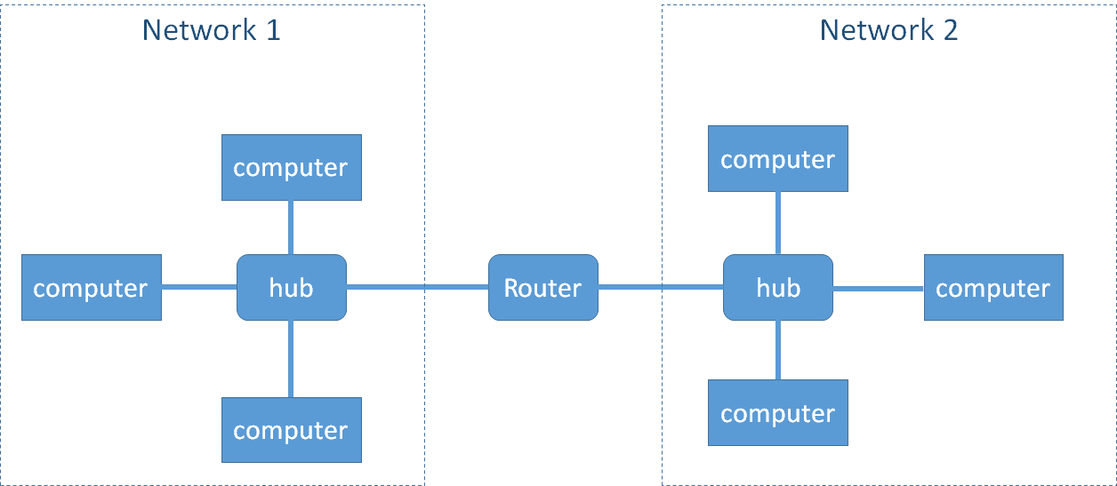

To connect networks, a computer must be on both networks and forward messages
Circuit Switching – virtual circuits using switches on each network, reserved bandwidth
Packet Switching – each packet has a destination, routers forward between networks

The internet is a large packet switched, composite network with many routers

Challenges:
- Addressing across many different networks
- Varying bandwidth
- Changing connections and properties over time
- Asynchronous nature of communication
- Not guaranteed to arrive in order
- Not guaranteed to arrive at all!

Open Systems Interconnection Model
OSI model abstracts communication allowing disparate systems to interconnect
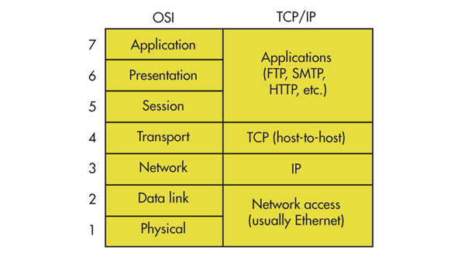

Layers:
- Physical – Medium used for actual communication (wires, radio, …)
- Data Link – Controls physical layer to send/receive data from point to point, represented in bits and frames, e.g. Ethernet protocol, identifies nodes with a MAC (medium access control) address
- Network – Moves data in packets from machine to machine and across connected networks, identifies nodes with a network address
- Transport – Ensures data is reliably moved from machine to machine
- Session – Control of dialogs involving multiple messages, including synchronization and error recovery
- Presentation – Deals with different types of data serialized/deserialized and complex data types
- Application – Abstraction of protocol used by applications

Addressing
Addresses are needed to identify nodes on a network
Generally need one at each layer, and vary in type/format

Data Link Address – identifies node on the physical network
Network Address – identifies node across networks

Internet Protocol (IP)
IP is at layer 3 Network
IP addresses are meant to be unique across the internet, but there are not enough
Network Address Translation (NAT) and other techniques are used to ensure at least one gateway on the internet has a unique address
IP takes care of forwarding through routers

Transmission Control Protocol (TCP) is at layer 4 Transport
Ensures delivery, or time-out, through acknowledgements
Ensures order of packets through sequence numbers and time stamps

Ports are numbers that identify a TCP service on a node

Network messages have headers and content
Header includes routing and control information (think “envelope”)
Content is the data to be included in the actual message
Each layer has a format for their messages
The layers above, include their messages in the content of the layers below
Ethernet at Layer 2, uses frames of fixed size header/content/footer
IP at Layer 3, uses packets, included in content spread across multiple frames
TCP at Layer 4, uses segments, included in content spread across multiple packets

Layer 5-7 protocols on the internet include HTTP, HTTPS, FTP, Telnet, SSH and so on
They each…
- Establish a session between client/server on behalf of an application
- Allow data of specific types to be sent/received through the protocol
- Make use of TCP/IP

Quick note: UDP is also a Layer 4 protocol, parallel to TCP. It does not guarantee receipt or order of packets. It is faster and used for some protocols that need maximum bandwidth, like file sharing. Requires higher level protocol to guarantee delivery.

TCP vs UDP
Basically…
TCP is a reliable, connected protocol
UDP is an unreliable, fire-and-forget protocol

TCP (stream) | UDP (datagram)
Behaves like a file  Individual writes can be combined or split  Bytes are guaranteed to arrive  Bytes are guaranteed to arrive in correct order  Connection based | Data sent a message at a time  Messages can be dropped  Messages can be delivered out of order  Connectionless

Sockets
Sockets are a paradigm for representing TCP or UDP end-points
Network libraries include class, structures and functions for working with sockets

Sockets are “bound” to address/port to listen, or when connected

Following shows how a TCP client and server uses sockets to connect and exchange info:

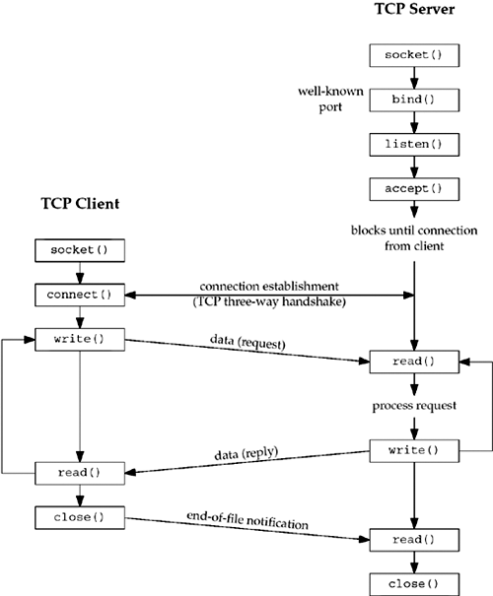

Following diagram shows what happens underneath in TCP socket states and messages:

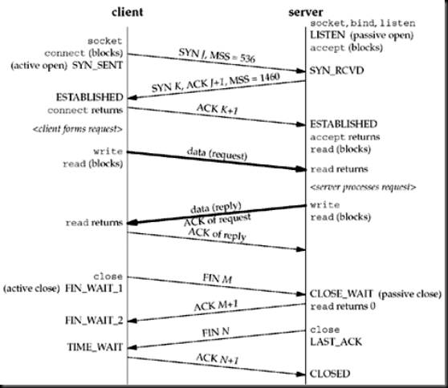

More on this later!

Following describes how a simple UDP service works:

- Create a socket of type “Datagram”
- Bind socket to address/port
- Use “SendTo()” to send data to another end-point
- Use “ReceiveFrom()” to receive data sent to this address/port

Socket Libraries
System.Net.Sockets for C#.NET on Windows

Access to socket library | using System.Net;  System.Net.Sockets;
Socket type | Socket class
Address type | System.Net…  IPEndPoint class  IPAddress class
Address lookup | System.Net.Dns class  Dns.GetHostAddresses()
Bind | Socket.Bind()
UDP
New UDP socket | new Socket(  SocketType.Dgram,  ProtocolType.Udp)
UDP Send | Socket.SendTo()
UDP Receive | Socket.ReceiveFrom()
TCP
New TCP socket | new Socket(  SocketType.Stream,  ProtocolType.Tcp)
TCP Listen | Socket.Listen()
TCP Accept | Socket.Accept() // socket must be in listening state
TCP Connect | Socket.Connect()
TCP Send | Socket.Send()
TCP Receive | Socket.Receive()
TCP Disconnect | Socket.Close()  Socket.Disconnect()

Winsock for C++ on Windows
https://msdn.microsoft.com/en-us/library/windows/desktop/ms741416(v=vs.85).aspx

Sockets for C++ on UNIX
https://www.gnu.org/software/libc/manual/html_node/Sockets.html ← explanation
http://man7.org/linux/man-pages/man2/socket.2.html ← starting point for all functions

